BIOLOGY 121 OPTIONAL ECOLOGY WORKSHEET – ECOLOGY & EVOLUTION

The abundance of amphibians (frogs and salamanders) is declining worldwide with at least 41% of amphibian species at risk of extinction. One factor contributing to this decline is the chytrid fungus, *Batrachochytrium dendrobatidis* (also called the Bd fungus). This parasitic fungus grows in the skin of amphibians impairing the amphibian’s ability to absorb water and air, which can lead to death. Non-lethal effects can include lethargy and poor swimming ability, which can affect the amphibian’s ability to forage.

1. Evaluate whether the following statement is true and explain your reasoning: “If a frog becomes infected by the Bd fungus but does not die, we can be certain its fitness is unchanged.”

*B. dendrobatidis* inhabit moist soil and fresh water. Environmental factors, including temperature and moisture availability, can affect the abundance of the chytrid fungus.

1. Based on the following data (see table and figures below and on next page), in which one of the following three B.C. locations, A, B or C, will the chytrid fungus likely be the **most abundant**? Explain your answer. Be specific.

Table 1. Temperatures and Precipitation Conditions at 3 B.C. Lakes

|  |  |  |
| --- | --- | --- |
| Location: | Summer Temperature Range (°C) | Annual Precipitation (mm) |
| A | 4°C - 16°C | 8 mm |
| B | 24°C - 30°C | 208 mm |
| C | 17°C-24°C | 580 mm |

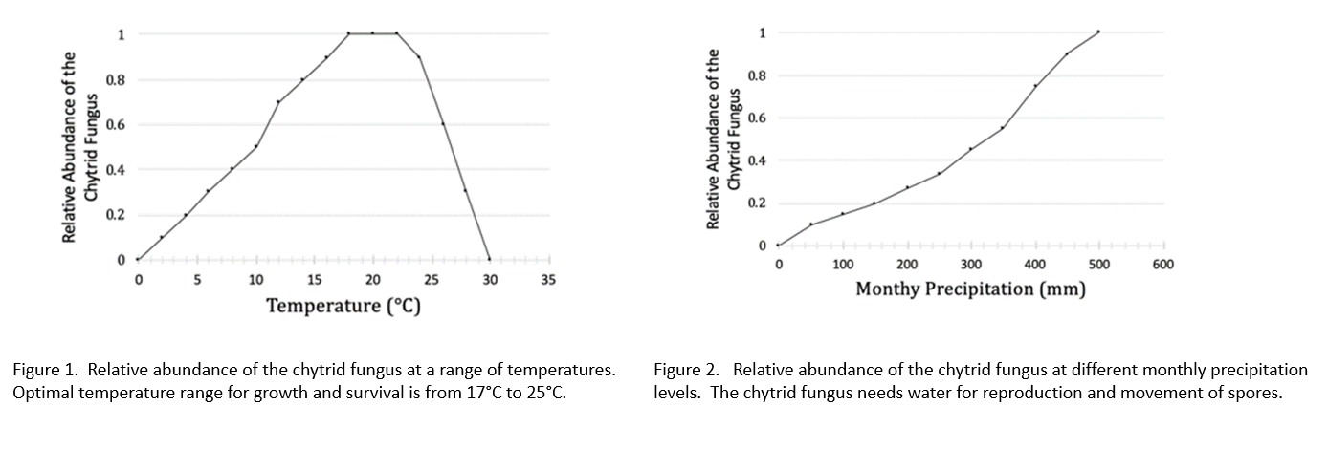

2. Research findings suggest that an aquatic invertebrate, *Daphnia major*, eats the spores of the Bd fungus, which is the infective stage of this fungus. The optimal temperature for *D. major* for foraging is around 20°C; and temperatures above 29°C are lethal. Given this new information, would you change your answer to question 1? Explain your answer.

3. There is evidence of emerging resistance to the Bd fungus in amphibian populations. Experiments suggest that amphibians that carry an allele, called the Q allele, have greater survivorship than individuals that carry the B allele for the same gene. Both alleles are involved in immune responses.

In Location B (see Table 1 above), the frog (*Rana pipiens*) population (N=150) includes 25 individuals that are homozygous for the Q gene, 120 individuals that are heterozygotes, and 5 individuals that are homozygous for the B allele.

Based on this data, is the frog population at Location B in HWE with respect to the immune system gene? Explain why or why not. Show your calculations.

Based on your understanding of HWE assumptions explain why this frog population may or may not be evolving with respect to this immune system gene.

4. Could resistance to the Bd fungus be classified as an adaptation for this frog population? Explain why or why not.